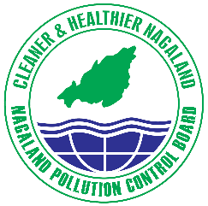
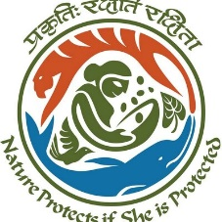

NOTIFICATION

Environmental Information System (ENVIS) Hub, Nagaland, Host Organization - Nagaland Pollution Control Board will be conducting a two-month Green Skill Development Programme (GSDP) Certificate Course on Bamboo Crafts at the ENVIS Hub, Nagaland Pollution Control Board, Signal Point, Dimapur from 28th January 2022 for 15 trainees. Any interested person in bamboo crafts may apply online to the Member Secretary, Nagaland Pollution Control Board at envisnagaland@gmail.com on/before 26th January 2022 along with the following details:
1. Name of the applicant,
2. Date of Birth,
3. Address (Correspondence/ Permanent),
4. Mobile Number,
5. Education qualification,
6. Aadhar Card (Mandatory) and
7. Scanned passport size photo.
Free accommodation & food will be provided for selected candidates.

For any enquiry Contact: 7085748263/8794808735

Sd/-
Member Secretary
Nagaland Pollution Control Board,
ENVIS Coordinator

